What was the issue on damage to sail bag when reefing?

**Sail bag and cover**

* Remove the sail cover from around the front of the mainsail, noting how it was tied up. The sail cover does not fit around the mast. The Velcro tapes are passed through the sail slides
* Unzip the sail bag from mast to boom end.

# Hoisting the Mainsail

Hoisting and lowering the mainsail requires two crew members in addition to the helmsman, one at the mast and another in the cockpit on the halyard winch.

* Attach the mainsail halyard to the headboard of the mainsail.
* Ensure there is no slack in the halyard and the halyard is not fouled in the lazy jacks.
* Ensure all reefing lines and their jammers are completely loose and the mainsheet and boom vang are eased.
* Bring the yacht head to wind under power at slow speed.
* Hoist the mainsail initially by hand at the mast, then on the halyard winch, watching the sail to ensure it runs up freely.
* The halyard can be pulled through the closed jammer
* Maintain the yacht head to wind, monitor the sail until it is fully hoisted and lightly tensioned. The sail luff and halyard will stretch a little over 20-30 minutes of use and can be re-tensioned with the Cunningham line.
* Jam the main halyard by pressing the jammer lever down, ease the halyard into the jammer. See image on page 2.
* Remove the halyard from the winch.
* Tension the boom vang and tidy reefing lines as required.

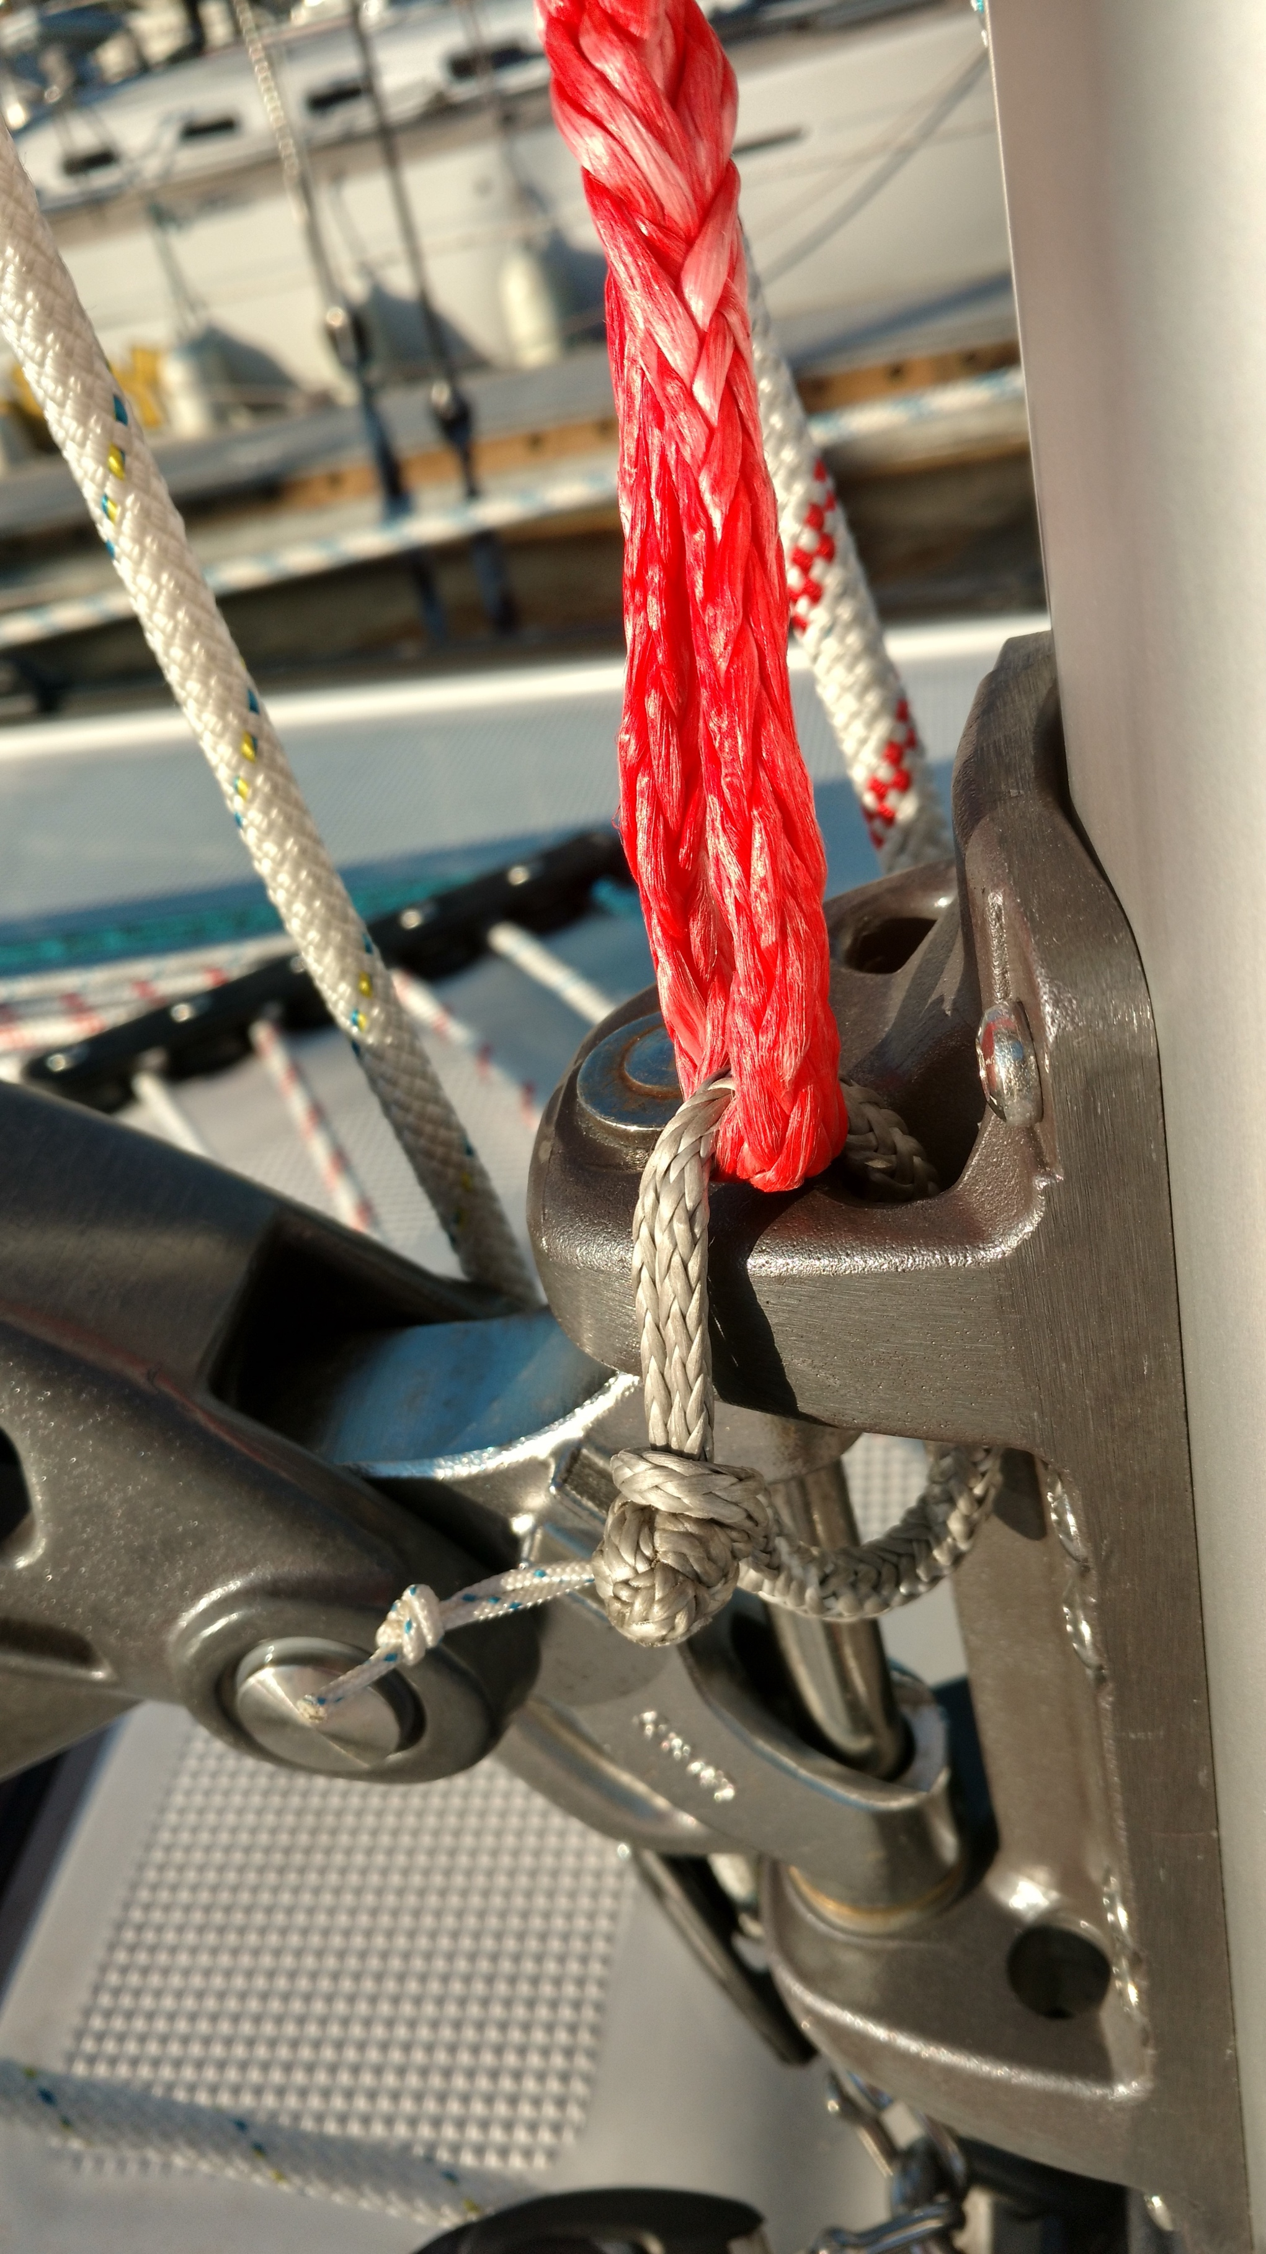**Cunningham**

* The Cunningham is rigged using the red dyneema line and soft shackle. It is attached to the base of the vang fitting.
* Lead the red Cunningham line and soft shackle through the first reef point and back to the vang attachment point.
* Gently tension the Cunningham on the winch in the coach house roof to remove luff wrinkles. Note that some wrinkles are good in light to moderate conditions.
* The Cunningham is also used as the 3rd reef luff line.

**European Main sheet system**

The yacht is fitted with a two line European mainsheet system. Each sheet is lead to winches and jammers on the coach house roof.

* You can use the windward or leeward sheets to control sail shape and boom position.
* The mainsheet system can be used to limit the boom movement in an accidental or controlled gybe.
* The system does not remove the need to rig an **end of boom** preventer.

# Lowering the Mainsail

* Bring the yacht head to wind under power at slow speed and centre the boom with the two mainsheets.
* Flake the halyard on the cockpit floor, free of twists and limbs.
* **Note**: the Spinlock jammer will only release after the load is secured on the winch.
* Put the main halyard on the halyard winch
* To release the Spinlock jammer press the lever in and lift it upwards.
* Take up the strain on the winch until you hear the jammer click
* Release the halyard through the jammer.
* Lower the mainsail rapidly and flake it on the boom.
* Zip up the boom bag and fit the mainsail cover to reduce UV damage to the sail.
* If necessary release the main halyard from the sail and attach to the end of the boom.
* The main halyard can be temporarily secured by one turn around a mast cleat.

**Reefing the Mainsail**

Ideally you need three people in the cockpit during reefing operations — one to steer, one to ease or hoist the main halyard, and one to winch in or release the reefing lines.

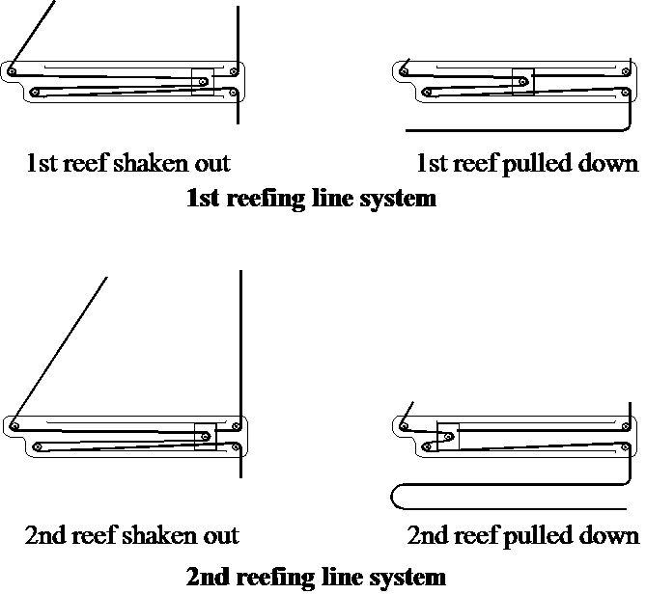**1st and 2nd reef system**

The 1st and 2nd reefs on Namadgi-3 are single line reefing systems in which the tension in the reefing line is converted to equal tension in both the luff line and the leech line. See the reef line diagram.

**3rd reef system**

The 3rd reef has one line that tensions the leech line only. The 3rd reef tack eye will be tensioned by the Cunningham line. Ideally you should rig the Cunningham into the 3rd reef tack eye when you set the 2nd reef. Otherwise the same procedure applies for the 3rd reef as the 1st and 2nd reef.

**To put in a reef:**

* Bring the yacht up to the wind when reefing.
* Ease the boom vang then the main sheet until the sail starts to flap. The boom must be free to ride up to the sail.
* Continue sailing on the genoa or use the diesel engine.
* Pull in loose reefing lines to stop them tangling around the backstay or boom end.

**To shake out a reef:**

* Bring the yacht up to the wind when shaking out a reef.
* Ease the boom vang and then the mainsail sheet
* Release the reefing line and winch in the mainsail halyard to the correct tension.
* Take in the mainsail sheet, then tension the vang.